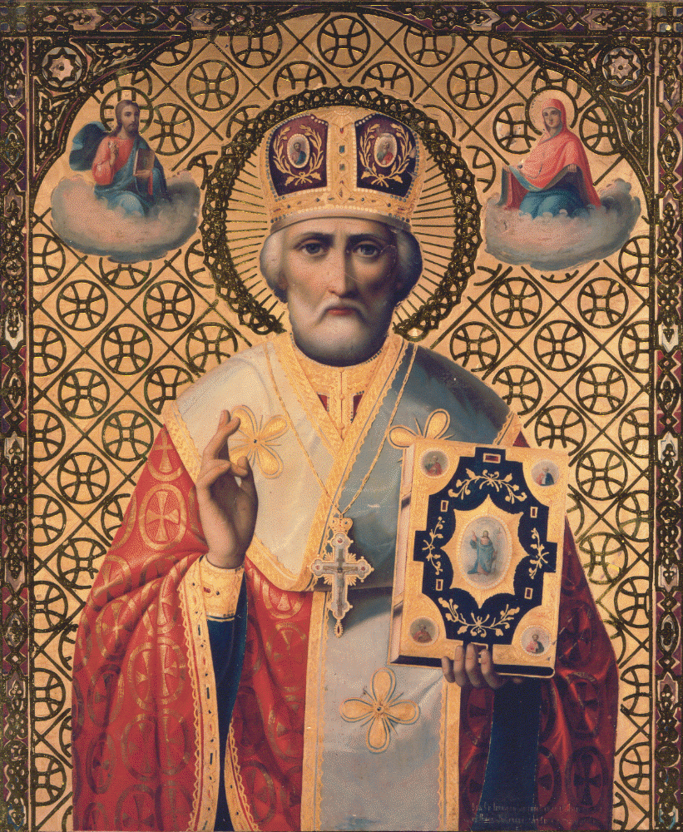

Tone 4
The truth of things revealed thee to thy flock / as a rule of faith, a model of meekness / and a teacher of temperance. / Therefore thou hast won the heights by humility, / riches by poverty. / Holy Father Nicholas, intercede with Christ our God // that our souls may be saved.

